Early beginnings of the Darley Dale and District Twinning Association

(as remembered by Shirley Davison – one of the founding members)

Today I had the pleasure of meeting 94 year old Shirley Davison, one of the founding members of the Darley Dale Twinning Association. She was aware that the most recent stalwarts of “twinning” in Darley Dale, namely Kevin Senior and Bill Jameson, had stood down from the committee in June 2024, after a combined tally of over 50 years’ service. She was keen to find out from me whether the legacy of close friendship between Darley Dale and Onzain, that she had help create over 35 years ago, was still alive and flourishing in 2025.

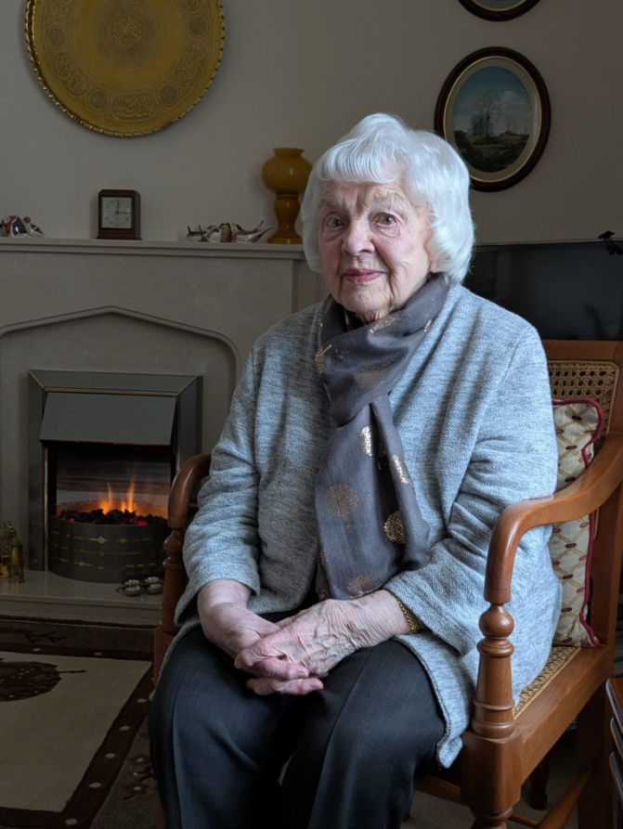

The meeting had been arranged by Christine Goldsack in her capacity as “chair” of Darley Dale in Bloom. This group has recently started to look for the first time at how they might create direct links with the gardeners of Onzain. After serving the coffee and handing out some lovely shortbread biscuits, Shirley settled down to listen to the plans which the “twinning” committee intend to “launch” at an informal “apero” event on Friday 14 March 2025. She was very enthused by the extent and range of ideas that I outlined to her and she had no hesitation at all in offering whatever help she could give. Clearly she still has a very deep and committed passion for the whole principle of “twinning”. Her enthusiasm for it is infectious and it’s inconceivable to think that anyone talking with her could fail to be inspired by her.

Her story, as far as “twinning” is concerned starts in the late 80s when, serving as a Darley Dale Town councillor she, and a couple of others thought the town would benefit from being twinned with a similar town overseas. With help and guidance from The British Council, Shirley waded her way through the many candidate profiles presented to her “…. but most of them just were n’t at all suitable for Darley Dale” Shirley told me “ they were mostly towns located on the edges of large cities and not at all similar to Darley”.

With a smile appearing on her face she remembered how she had been so thrilled when a much different candidate profile hit the top of her pile. “ From the moment I picked up the file of papers telling me about Onzain, I knew that this would be the place we chose. So much of Onzain was similar to Darley Dale, whilst there were also plenty of differences we could learn about over the years. The two towns are of a similar size, broadly located in a rural setting with agriculture a significant feature of the local economy. I couldn’t wait to visit.”

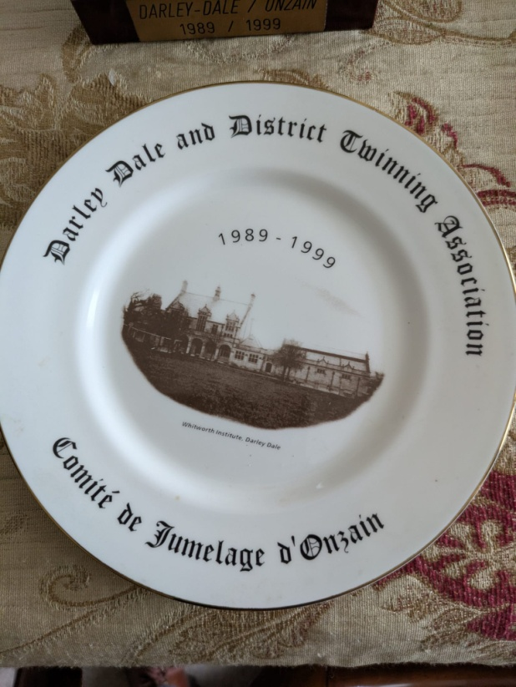Once the council had ratified Shirley’s assessment then she, as mayor, had to lead a civic group of councillors to Onzain as the first part of preparing the formal twinning agreements. “I realise now that the French absolutely love these formal occasions, with plenty of speeches and lots of food. I knew that I would be expected to give a speech and I had prepared something suitable with the help of Colette, a lady in Onzain, who since became (and still is at 104) a very good friend”.

“Whilst I had studied French as a degree subject and could read and write the language pretty competently, I really struggled with speaking it. My education had been at the end of the war and French “assistants” to help with pronunciation just weren’t available, which meant I had nobody to really guide me with speaking. Anyway, I think I got through the speech Ok. At the end of it they all came up to me thinking I was a fluent speaker, but I couldn’t actually understand a word of what they were saying! Still, I felt I had fully deserved the Michelin star restaurant they then took us off to. Twinning was proving to be very successful”.

Shirley clearly remembered many happy times involved with “twinning” as we sat and talked some more about exchange visits to Onzain and the return visits to Darley Dale by increasing numbers of French friends. “I have had some wonderful times through being a part of the twinning movement” she said, and for a moment drifted into a dream, in which all those happy times flashed by. “Of course it hasn’t always been easy and we have often struggled for host families for French visitors. I suppose it is quite natural to expect that people will be quite reluctant to host people with whom they can’t readily converse. It must be quite a daunting prospect and I’m not sure how we can convince them that instead of being something awful, it will nearly always be a most positive experience.” This point resonated squarely with my own, first experience of hosting in May 2024. I reassured her she was spot on with her assessment as from just 3 days of meeting Eve and Dani we had become good friends with them and whom we definitely want to meet up with again.

.

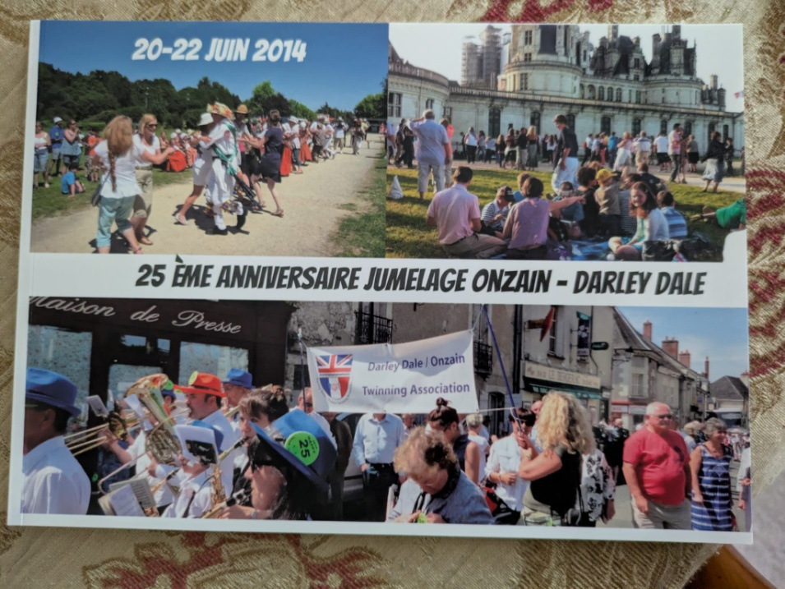

Eventually it was time to bring our reminiscing to a close, but before I left ….“I’d just like you to have a look at some of the memorabilia I have” she said, as she guided me across the room to where it had all been laid out. Many years of her memories were embedded in those pictures, but so too could I see so clearly that a lot of other people have been involved in the process of bringing the close links and friendships between Darley Dale & Onzain to where they are today. A result of hers and many others who have been dedicated and committed to “twinning” in this community.

As I left the room she had some final words of support and encouragement. “If there is anything else I can do to help you keep twinning alive and active in Darley Dale, please do let me know” If only we can spread her enthusiasm and commitment to others within the community in 2025, as she did back in 1989, then she will have more than done her bit to help.

I visited Shirley Davison at her apartments in St Elphins on Monday 20 January 2025.